**Lab5**

**Configure Elastic Beanstalk**

**Logged into AWS Account, click “Elastic Beanstalk”.**

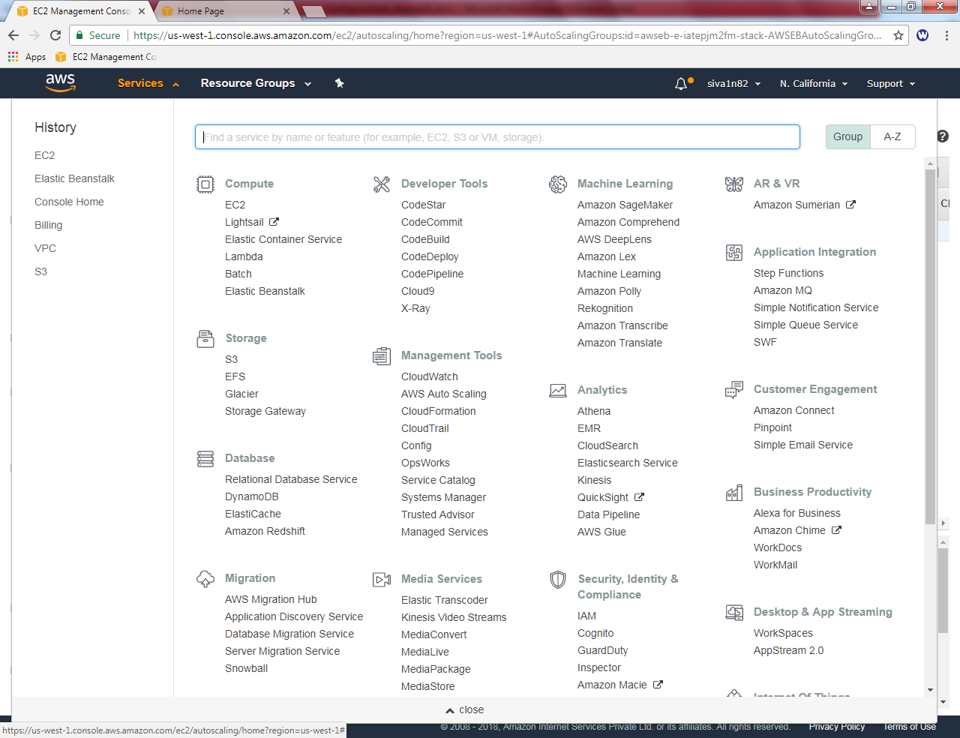

**Select .NET (Windows/IIS) and Click ”Launch now”**

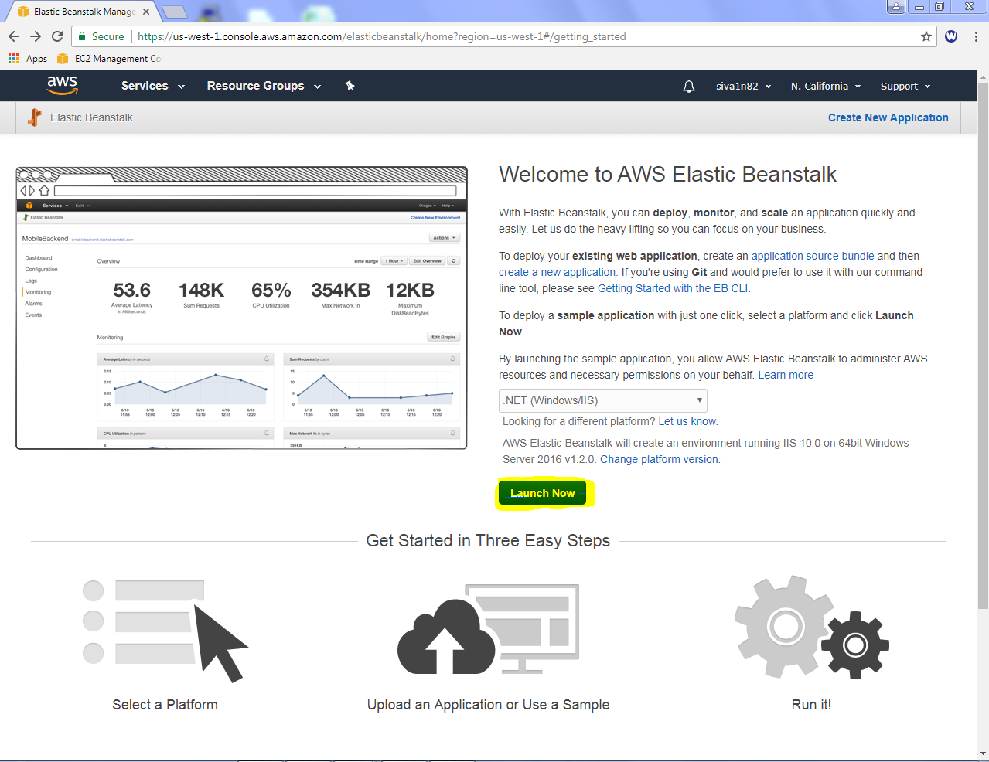

Wait for 10 minutes to deploy, after that you can able to see the health status in Greeen.

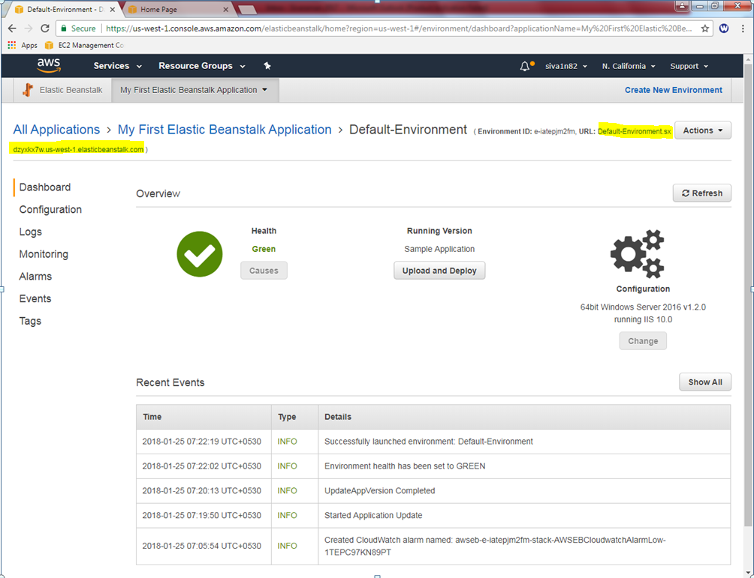

Click above URL to launch the Elastic Beanstalk webserver.

Now we have successfully connected the webserver.

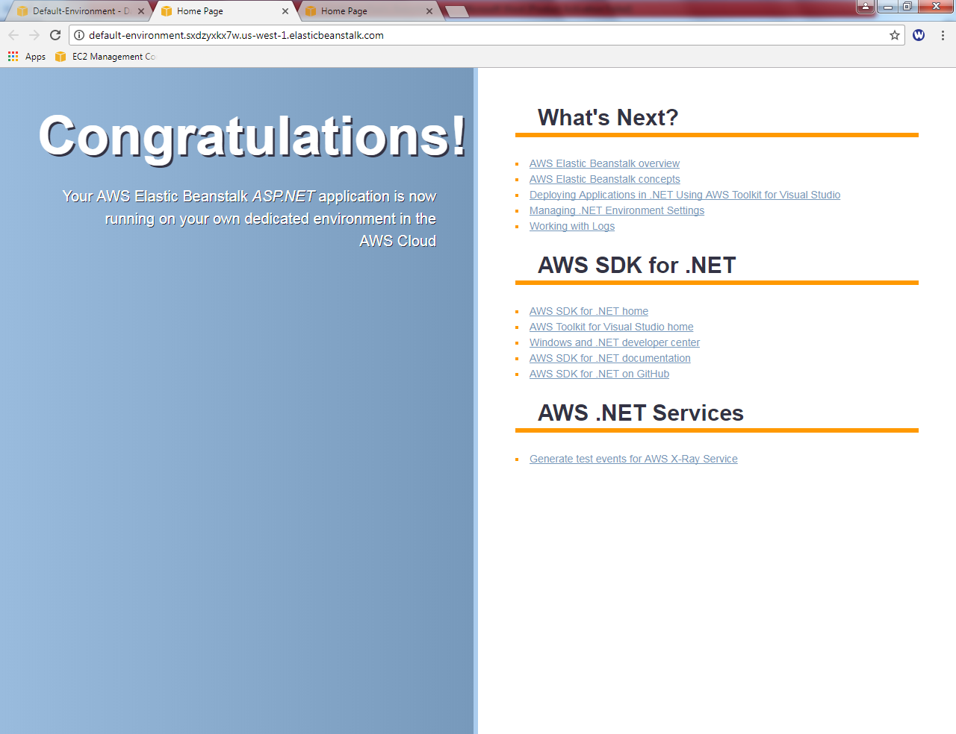

Now you need to remove the configurations part in aws console.

Click “Ec2”service.



In EC2, service click “Auto Scaling Groups” , then click the created group.

Right click “Auto scaling groups”, click delete to delete auto scaling group.

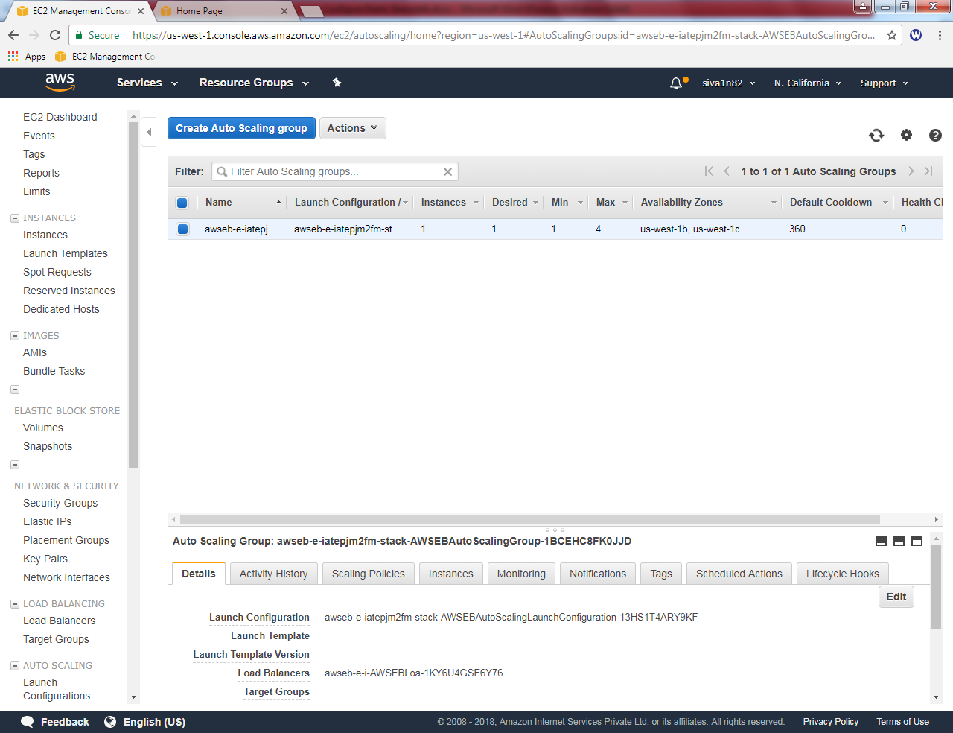

Now auto scaling group has been deleted.

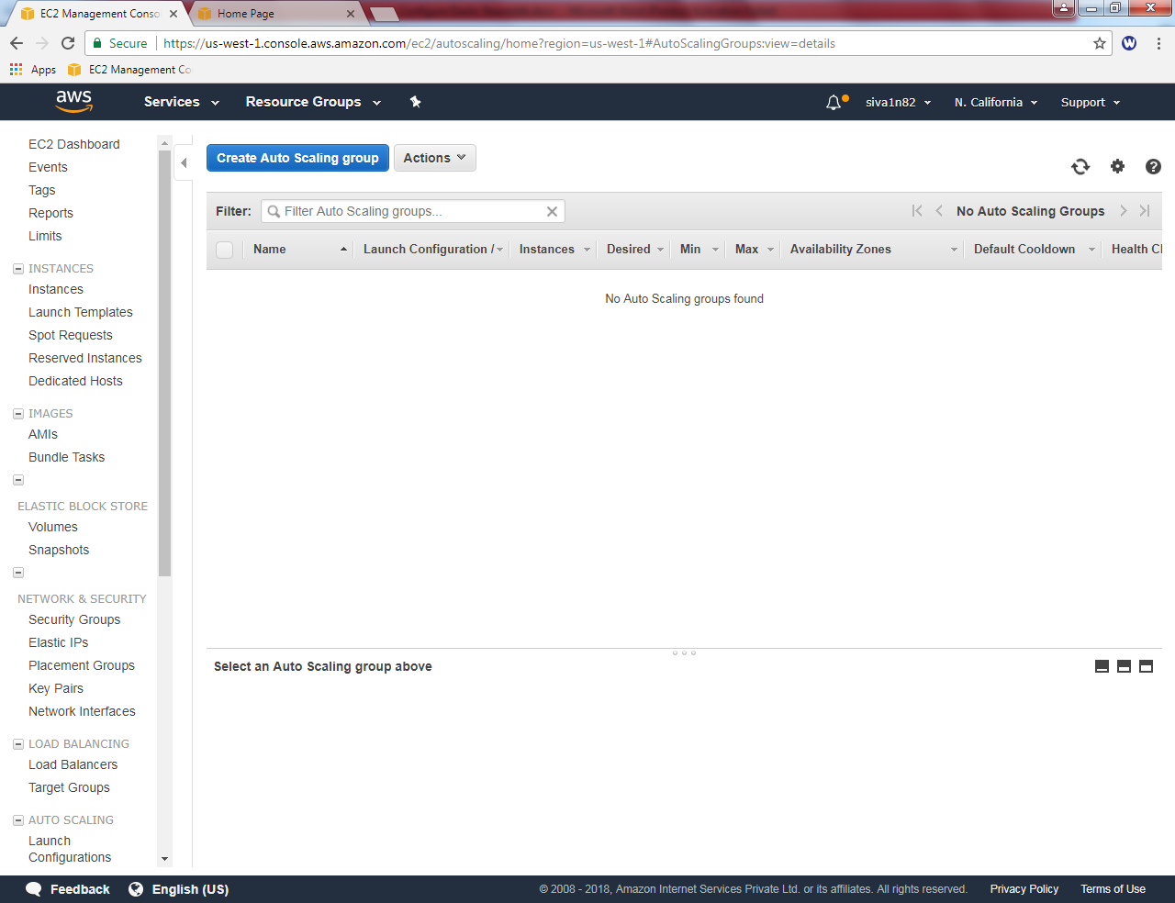

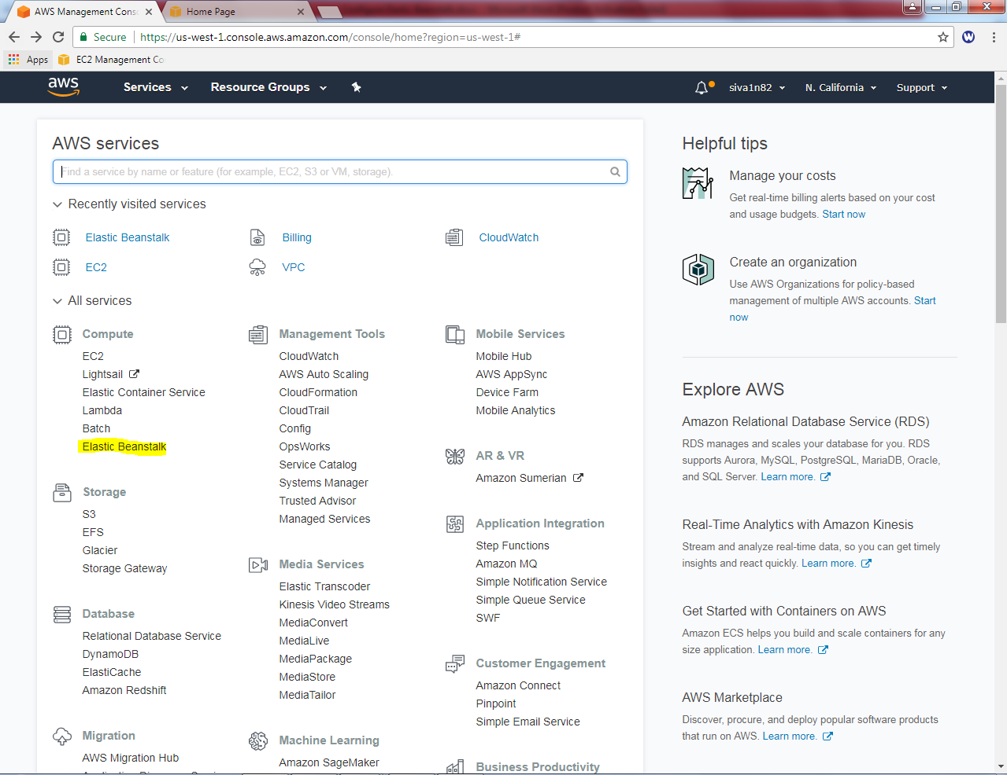

Click “Default environment”.

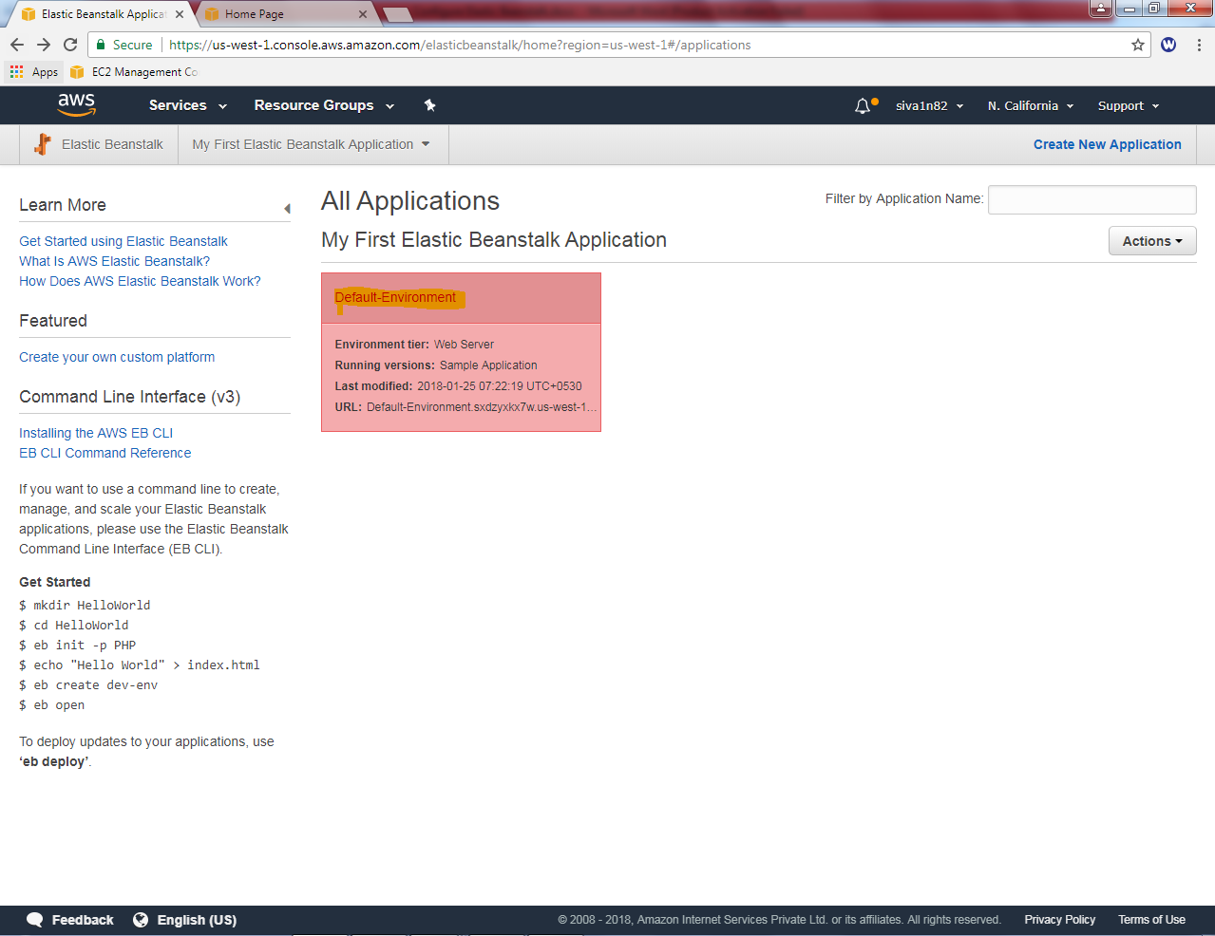

Click “Terminate Environment”.

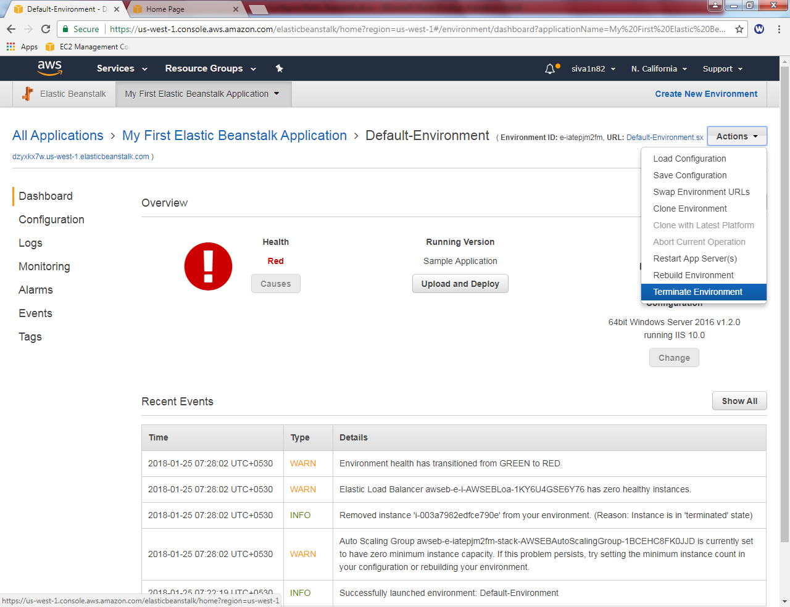

Type the Environment name i.e. “Default-Environment” then click “Terminate”.

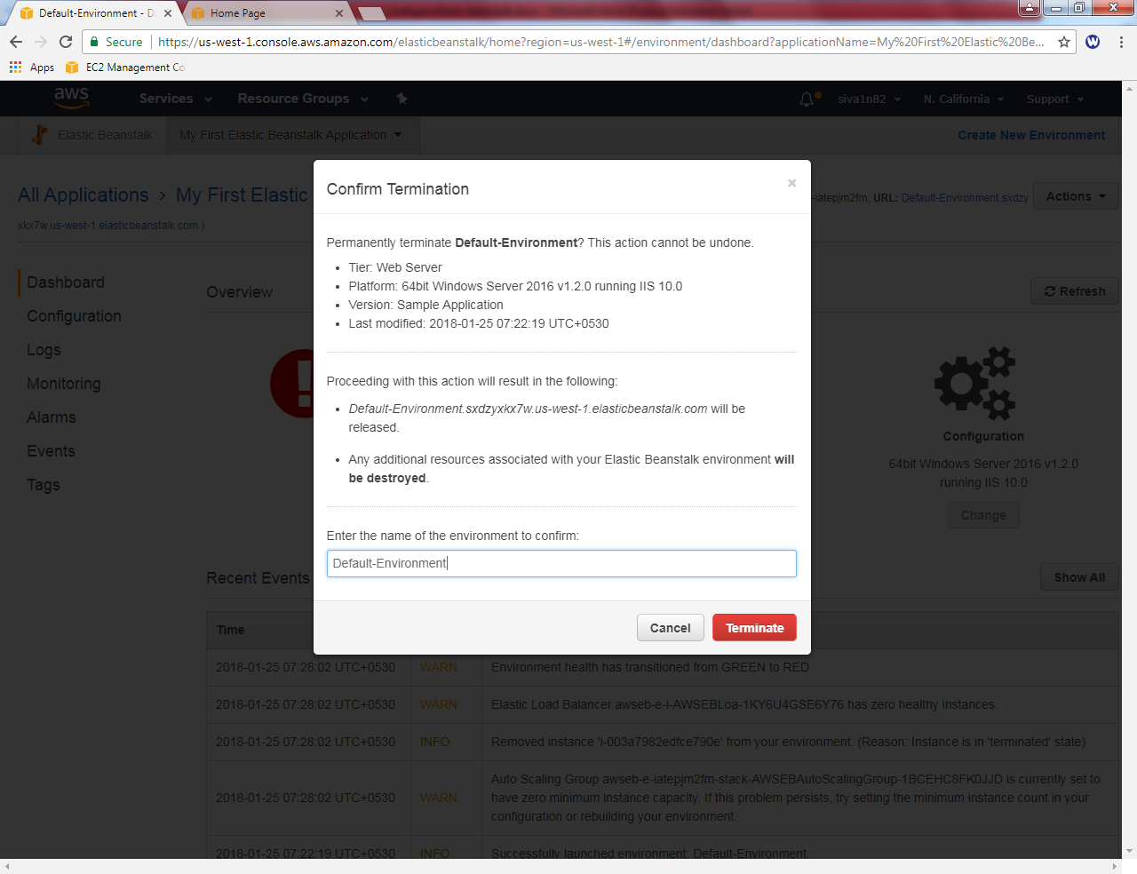

Now Elastic Beanstalk “Default environment“ has been successfully terminated.

